Introduction:
The skeletal system is a primary system of the human body that involves many components with multiple functions. The objective of this Jab is to identify to first identify the pattern of motion of the joints in the skeletal system by comparing them to mechanical joints; In the second part of the lab, you will measure the range of motion of a body joint using a measurement tool and compare your results.

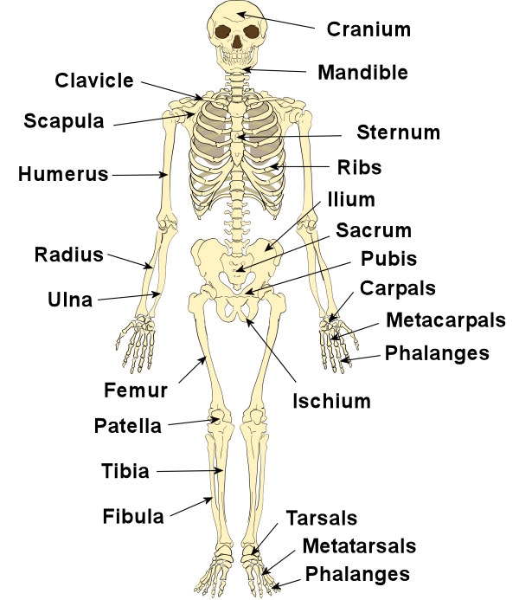

Figure 1: The primary bones in the skeletal system.

- Based on what you have learned in engineering mechanics, anatomy and physiology and biomechanics, pick 5 large joints of the body and name the appropriate mechanical joint (Hinge, Ball & Socket, slider, etc) that can represent the anatomical function of that joint.

Part 2: Joint Kinematics

Lower extremity joint have crucial roles in movement of lower body. Figure 2 shows the body of a subject in two positions, upright standing and half squat. In this exercise we want to measure the angle of the knee and the ankle joints with body in two postures as shown and see the difference.

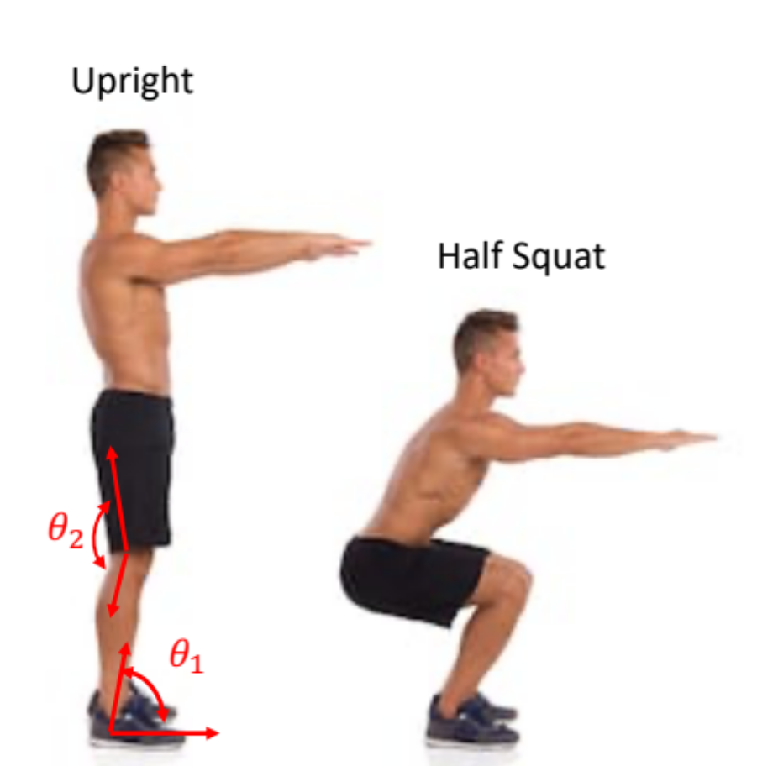

Figure 2: Subject showing upright and squat postures.

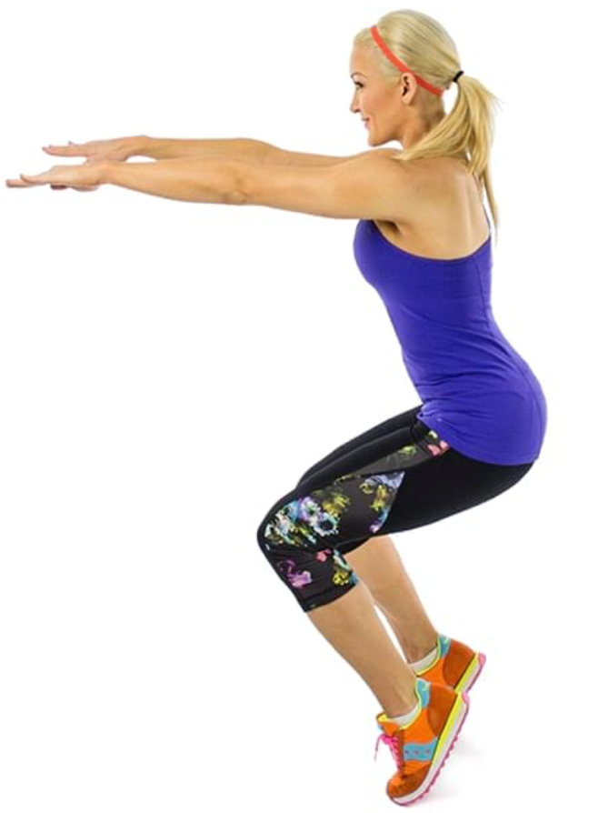

Figure 3: Subject in on-toe half squat posture .

Procedure:
- Perform the squat motion as shown in figures 1 & 2 and measure the angles of the knee and ankle joint using goniometer in these three postures: upright, half-squat foot flat, on-toe square (figure 3).
- Perform three measurements for each posture and type the angles in tables 1 and 2.

Exercise:

- Perform lower limb exercises as shown in figure 4. Do each exercise two times and hold body in shown posture for at least 5 seconds.
- Repeat steps 1-2 and record the angles and add them to tables 3 & 4.

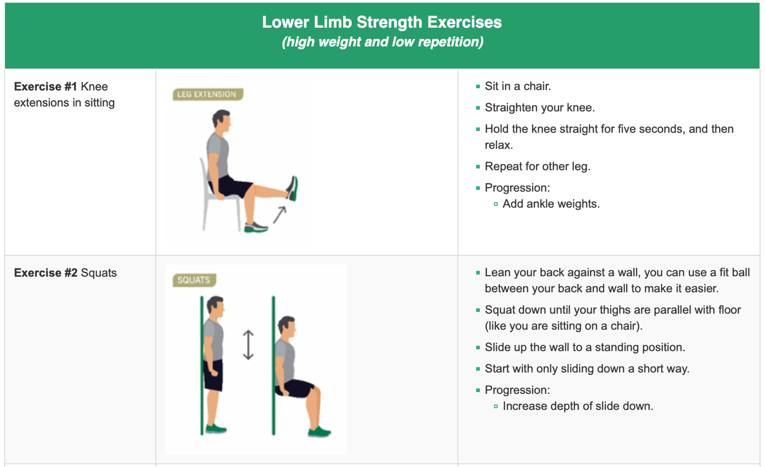
Figure 4: Lower limb exercise.

Tables:
Table 1 (Knee angle Before exercise):

Position-Angle: | Left knee angle (deg) |  |  | Right knee angle (deg)
Position-Angle: | Upright | Half Squat (foot flat) | Half Squat (on toe) | Upright | Half Squat (foot flat) | Half Squat (on toe)
Trial 1 | 3 | 76 | 80 | 3 | 76 | 80
Trial 2 | 3 | 76 | 79 | 3 | 76 | 80
Trial 3 | 3 | 76 | 81 | 3 | 76 | 80
Average | 3 | 76 | 80 | 3 | 76 | 80

Table 2 (Ankle angle Before exercise):

Position-Angle: | Left ankle angle (deg) |  |  | Right ankle angle (deg)
Position-Angle: | Upright | Half Squat (foot flat) | Half Squat (on toe) | Upright | Half Squat (foot flat) | Half Squat (on toe)
Trial 1 | 84 | 106 | 110 | 84 | 106 | 110
Trial 2 | 84 | 107 | 111 | 84 | 107 | 111
Trial 3 | 84 | 105 | 109 | 84 | 105 | 109
Average | 84 | 105 | 110 | 84 | 105 | 110

Table 3 (Knee angle After exercise):

Position-Angle: | Left knee angle (deg) |  |  | Right knee angle (deg)
Position-Angle: | Upright | Half Squat (foot flat) | Half Squat (on toe) | Upright | Half Squat (foot flat) | Half Squat (on toe)
Trial 1 | 3 | 85 | 86 | 3 | 85 | 86
Trial 2 | 3 | 84 | 90 | 3 | 84 | 90
Trial 3 | 3 | 86 | 88 | 3 | 86 | 88
Average | 3 | 85 | 88 | 3 | 85 | 88

Table 4 (Ankle angle after exercise):

Position-Angle: | Left ankle angle (deg) |  |  | Right ankle angle (deg)
Position-Angle: | Upright | Half Squat (foot flat) | Half Squat (on toe) | Upright | Half Squat (foot flat) | Half Squat (on toe)
Trial 1 | 90 | 111 | 114 | 90 | 111 | 114
Trial 2 | 90 | 112 | 114 | 90 | 110 | 114
Trial 3 | 90 | 110 | 114 | 90 | 112 | 114
Average | 90 | 111 | 114 | 90 | 111 | 114

Knee and Ankle motions measurement experiment:

- How does the angle of your left knee and ankle joints compares against the angle of the right side joints in half squat flat foot posture ?
- How does the angle of your left knee and ankle joints compares against the angle of the right side joints in on-toe half squat posture ?
- How does the angle of the knee joint (left or right) in squat (flat foot) differs from the angle of the joint in on-toe squat posture ?
- How does the angle of the ankle joint (left or right) in squat (flat foot) differs from the angle of the joint in on-toe squat ?
- In which posture (flat foot versus on-toe) you feel more muscle forces being applied to your bones ? explain from biomechanics perspective.
- In which posture (flat foot versus on-toe) it is more difficult to maintain body’s stability, why ?
- Does exercise have any impact on the angle of the knee and the ankle joints in squat (flat foot) and on-toe squat postures ? explain from biomechanics perspective.

